Base URL: <http://api.translationnetwork.org>

# GET FEATURED ARTICLES

## GET /articles?featured=1

Returns only the featured articles in the database

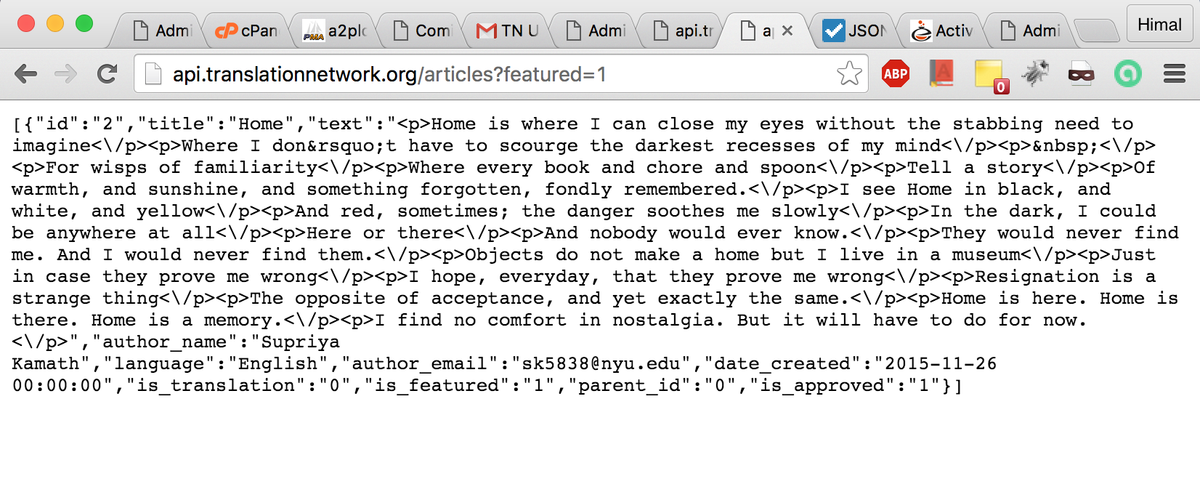

Response:

[    
   {    
      **"id"**:"2",  
      **"title"**:"Home",  
      **"text"**:"<p>Home is where I can close my eyes without the stabbing need to imagine<\/p><p>Where I don&rsquo;t have to scourge the darkest recesses of my mind<\/p><p>&nbsp;<\/p><p>For wisps of familiarity<\/p><p>Where every book and chore and spoon<\/p><p>Tell a story<\/p><p>Of warmth, and sunshine, and something forgotten, fondly remembered.<\/p><p>I see Home in black, and white, and yellow<\/p><p>And red, sometimes; the danger soothes me slowly<\/p><p>In the dark, I could be anywhere at all<\/p><p>Here or there<\/p><p>And nobody would ever know.<\/p><p>They would never find me. And I would never find them.<\/p><p>Objects do not make a home but I live in a museum<\/p><p>Just in case they prove me wrong<\/p><p>I hope, everyday, that they prove me wrong<\/p><p>Resignation is a strange thing<\/p><p>The opposite of acceptance, and yet exactly the same.<\/p><p>Home is here. Home is there. Home is a memory.<\/p><p>I find no comfort in nostalgia. But it will have to do for now.<\/p>",  
      **"author_name"**:"Supriya Kamath",  
      **"language"**:"English",  
      **"author_email"**:"sk5838@nyu.edu",  
      **"date_created"**:"2015-11-26 00:00:00",  
      **"is_translation"**:"0",  
      **"is_featured"**:"1",  
      **"parent_id"**:"0",  
      **"is_approved"**:"1"  
   }  
]

# FOR SEARCH

## Auto-Completion

## GET **/languages**

Returns the list of all languages present in the database

Response:

[    
   "Arabic (Khaleeji)",  
   "English",  
   "Hindi",  
   "Maori"  
]

GET **/authors**

Returns the list of all author names present in the database

Response:

[    
   "Megan Eloise",  
   "Mohamed Al-Mubarak",  
   "Pranav Mehta",  
   "Supriya Kamath",  
   "Vlad Maksimov"  
]

## Searching

GET **/search?language=[SEARCH_KEY]**

[SEARCH_KEY] is case-insensitive i.e. ENglish = english

[SEARCH_KEY] must be minimum of 3 characters to return something. Example, “En” returns nothing while “ENg” or “engl” returns something.

Examples:

/search?language=engli

Response:

[    
   {    
      **"id"**:"1",  
      **"author_name"**:"Vlad Maksimov",  
      **"title"**:"Discomfort of Home",  
      **"is_translation"**:"0",  
      **"language"**:"**Engli**sh",  
      **"parent_id"**:"0"  
   },  
   {    
      **"id"**:"2",  
      **"author_name"**:"Supriya Kamath",  
      **"title"**:"Home",  
      **"is_translation"**:"0",  
      **"language"**:"**Engli**sh",  
      **"parent_id"**:"0"  
   },  
   {    
      **"id"**:"6",  
      **"author_name"**:"Megan Eloise",  
      **"title"**:"Home is a language.",  
      **"is_translation"**:"1",  
      **"language"**:"**Engli**sh",  
      **"parent_id"**:"5",  
      **"parent_title"**:"K\u0101inga ko Te Reo"  
   }  
]

GET **/search?author=[SEARCH_KEY]**

[SEARCH_KEY] is case-insensitive i.e. MEgaN = megan

[SEARCH_KEY] must be minimum of 3 characters to return something. Example, “Me” returns nothing while “meG” or “megan” returns something.

Examples:

/search?author=**eloise**

Response:

[    
   {    
      **"id"**:"4",  
      **"author_name"**:"Megan **Eloise**",  
      **"title"**:"K\u0101inga ko Te Reo",  
      **"is_translation"**:"0",  
      **"language"**:"Maori",  
      **"parent_id"**:"0"  
   },  
   {    
      **"id"**:"6",  
      **"author_name"**:"Megan **Eloise**",  
      **"title"**:"El hogar es un idioma.",  
      **"is_translation"**:"1",  
      **"language"**:"Spanish",  
      **"parent_id"**:"5",  
      **"parent_title"**:"Home is a language."  
   }  
]

GET **/search?title=[SEARCH_KEY]**

[SEARCH_KEY] is case-insensitive i.e. hoMe = home

[SEARCH_KEY] must be minimum of 3 characters to return something. Example, “Ho” returns nothing while “hoM” or “home” returns something.

Examples:

/search?title=**home**

Response:

[    
   {    
      **"id"**:"1",  
      **"author_name"**:"Vlad Maksimov",  
      **"title"**:"Discomfort of **Home**",  
      **"is_translation"**:"0",  
      **"language"**:"English",  
      **"parent_id"**:"0"  
   },  
   {    
      **"id"**:"2",  
      **"author_name"**:"Supriya Kamath",  
      **"title"**:"**Home**",  
      **"is_translation"**:"0",  
      **"language"**:"English",  
      **"parent_id"**:"0"  
   }  
]

If the user enters a string with spaces (example, “home disc”), you should append the two words separated by spaces by a + sign, like the way Google does. Then, the API would only return articles whose titles have both words (“home” and “disc”).

Example:

/search?title=**home**+**disc**

Response:

[    
   {    
      **"id"**:"1",  
      **"author_name"**:"Vlad Maksimov",  
      **"title"**:"**Disc**omfort of **Home**",  
      **"is_translation"**:"0",  
      **"language"**:"English",  
      **"parent_id"**:"0"  
   }  
]

*The same strategy works for the /search?author=[SEARCH KEY] as well.*

# GET ARTICLE (DATA) BY ID

## GET /article/[ID]

Returns JSON data for matching [ID].

[ID] is a numeric value.

[ID] should be taken from the returned search data and used with AJAX GET query to retrieve complete data about that ID.

Example:

GET /article/6

Response:

{    
   **"id"**:"6",  
   **"title"**:"El hogar es un idioma.",  
   **"text"**:"<p>Aunque mi padre no puede hablar Te Reo y yo no entiendo mucho, estoy aprendiendo. Pero quien podr&iacute;a ense&ntilde;arme? Qu&eacute; se puede hacer?<\/p><p>Despu&eacute;s de Abu Dhabi, voy a volver a mi hogar. El mundo es grande, pero conf&iacute;o en mi misma que alg&uacute;n d&iacute;a volver&eacute;. No olvidemos nuestro idioma, no olvidemos nuestro hogar.<\/p>",  
   **"author_name"**:"Megan Eloise",  
   **"language"**:"Spanish",  
   **"author_email"**:"meganeloisevincent@gmail.com",  
   **"date_created"**:"2015-11-28 10:48:14",  
   **"is_translation"**:"1",  
   **"is_featured"**:"0",  
   **"parent_id"**:"5",  
   **"is_approved"**:"1"  
}

GET /article/4

{    
   **"id"**:"4",  
   **"title"**:"K\u0101inga ko Te Reo",  
   **"text"**:"<p>Ahakoa k\u0101ore a Papa i te korero a kaore au e m\u0101rama nui ka haere au ki te mahi. Engari ma wai aha e ako? Me aha?<\/p><p>E ako tonu ana ahau, a I muri i te Abu Dhabi ka hoki mai ahau. Ko nui te ao engari, otiia e u ana toku whakaaro i roto i te ahau, ka hohoro toku tae atu. Kei wareware i a t\u0101tou to tatou reo, a kei wareware i a t\u0101tou te k\u0101inga.<\/p>",  
   **"author_name"**:"Megan Eloise",  
   **"language"**:"Maori",  
   **"author_email"**:"meganeloisevincent@gmail.com",  
   **"date_created"**:"2015-11-28 10:48:14",  
   **"is_translation"**:"0",  
   **"is_featured"**:"0",  
   **"parent_id"**:"0",  
   **"is_approved"**:"1",  
   **"translations"**:[    
      "6"  
   ]  
}

If an invalid ID is supplied, you get the error response.

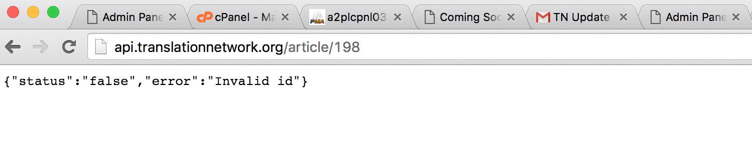

# CREATING NEW ARTICLE

POST **http://translationnetwork.org/api/index.php/article**

NOTE [IMPORTANT]: You have to use this specific url and the code highlighted in yellow ($.post jQuery function). I tried using the normal ones, but they didn’t work.

var jsonData = {

"title" : "Test: Hello World",

"author_email" : "himal.shrestha@nyu.edu",

"editor": "This is for test purpose only.",

"author_name" : "Himal Shrestha",

"language" : "English",

"is_translation" : "0",

"parent_id" : "0"

};

[IMPORTANT] The name of the form fields in the “Create new submission” form should exactly be the strings highlighted in red above.

$.post("**http://translationnetwork.org/api/index.php/article** ", jsonData,

function(data)

{

console.log(data.status);

});